# Week 4 Rest

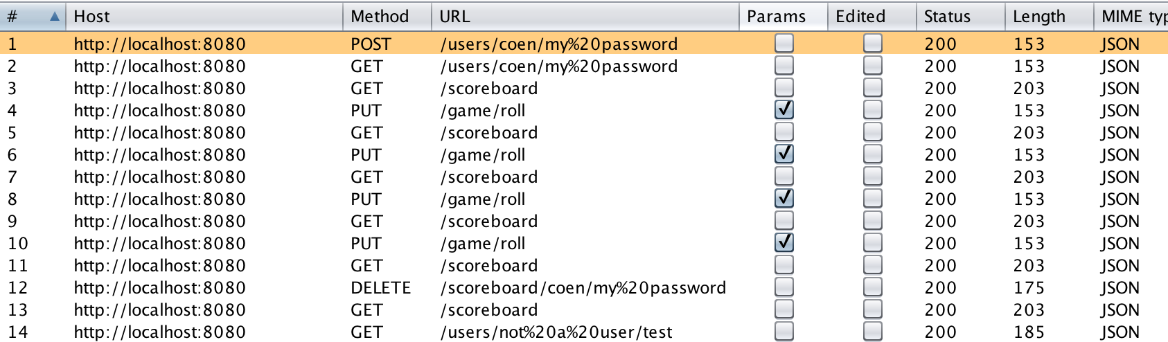

## GET

The GET is used within the application to login and to get the scoreboard. The login has a custom error message implemented like such:

HTTP/1.1 200

Content-Type: application/json

Date: Tue, 26 Sep 2017 10:47:28 GMT

Connection: close

Content-Length: 28

{"succes":true,"message":""}